**9 Build Chemistry - Quick Quiz 3**

Name: ___________________________________

**How much do you know and understand? Answer each question to the best of your ability.**

1. The nucleus of an atom contains___________

a. protons and electrons

b. just electrons

c. neutrons and electrons

d. neutrons and protons

1. Electrons are:

a. positively charged

b. negatively charged

c. neutral

d. always equal to the number of neutrons in an atom

1. Label the parts of this atom:

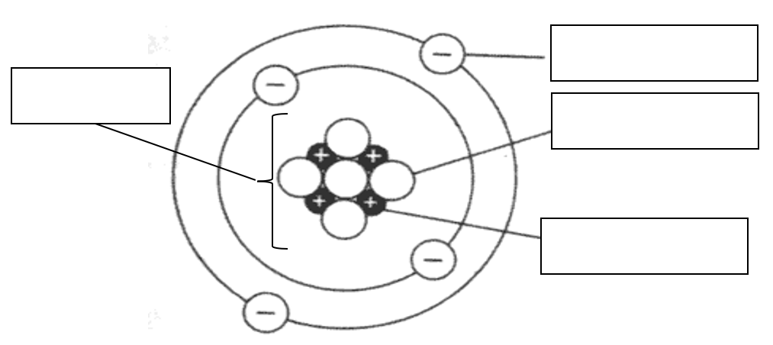

1. Label the arrows on the diagram below with the radiation (alpha, beta or gamma) it represents.

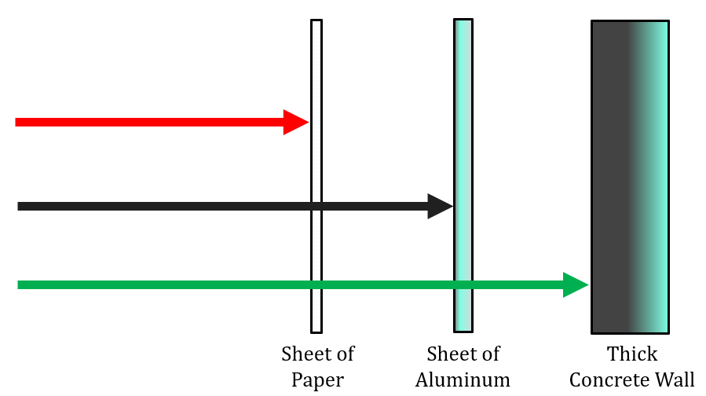

1. List two signs of a chemical reaction occurring.



1. The following is a word equation of a common chemical reaction

methane + oxygen → carbon dioxide + water

Complete the table to show the reactants and products for this reaction.

|  |  |
| --- | --- |
| **Reactants** | **Products** |
|  |  |

1. The production of magnesium oxide gives a bright white colour. This comes from the reaction between magnesium and oxygen.
   1. Complete the table to show the reactants and products for this reaction.

|  |  |
| --- | --- |
| **Reactants** | **Products** |
|  |  |

* 1. Write a word equation for this reaction

|  |  |  |
| --- | --- | --- |
|  |  |  |
|  |  |  |
|  |  |  |
|  |  |  |